**– Pembuatan Database –**

Create Database Pertemuan5_Cahaya;

use Pertemuan5_Cahaya;

create table data_mahasiswa(

npm nvarchar(12),

nama nvarchar(20),

fakultas nvarchar(50),

kelas nvarchar(12),

umur int);

insert into data_mahasiswa values

('11776824','Danu','Ilmu Komputer','3KA20',21),

('10122883','Andi','Teknologi Industri','3IA13',22),

('11003842','Ahmad','Teknologi Industri','3IA10',20),

('12678988','Rendy','Ilmu Komputer','3KA01',22),

('10094736','Zein','Teknologi Industri','3IA17',21),

('10112400','Arum','Ilmu Komputer','3KA22',20),

('11267789','Tyas','Ilmu Komputer','3KA14',23);

**– Design –**

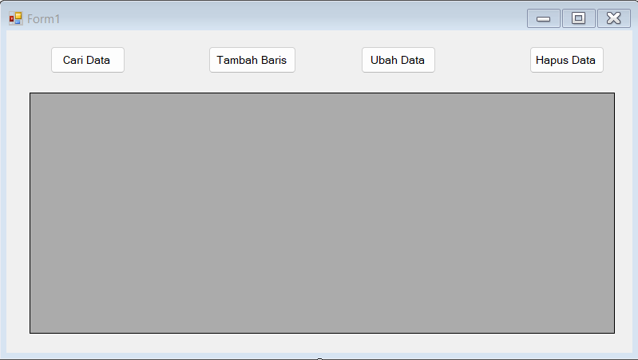

**– Codingan Form1.vb –**

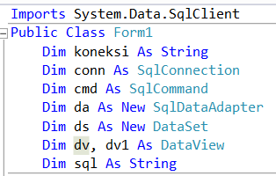

**Dim koneksi As String**

**Dim conn As SqlConnection**

**Dim cmd As SqlCommand**

**Dim da As New SqlDataAdapter**

**Dim ds As New DataSet**

**Dim dv, dv1 As DataView**

**Dim sql As String**

**– Codingan Form1_Load –**

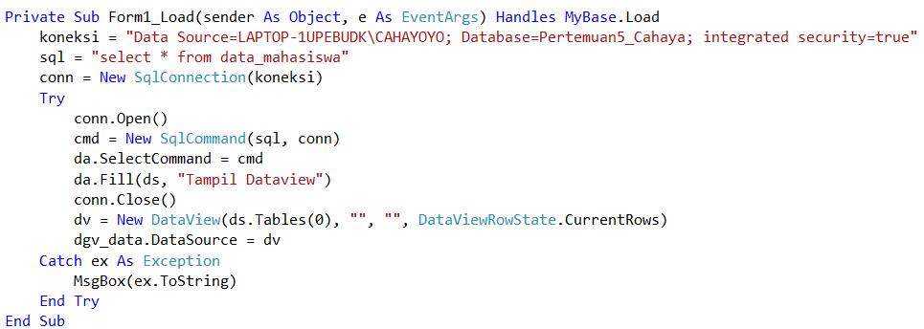

**koneksi = "Data Source=LAPTOP-1UPEBUDK\CAHAYOYO; Database=ical_12115408; integrated security=true"**

**sql = "select * from data_mahasiswa"**

**conn = New SqlConnection(koneksi)**

**Try**

**conn.Open()**

**cmd = New SqlCommand(sql, conn)**

**da.SelectCommand = cmd**

**da.Fill(ds, "Tampil Dataview")**

**conn.Close()**

**dv = New DataView(ds.Tables(0), "", "", DataViewRowState.CurrentRows)**

**dgv_data.DataSource = dv**

**Catch ex As Exception**

**MsgBox(ex.ToString)**

**End Try**

**– Codingan btn_caridata –**

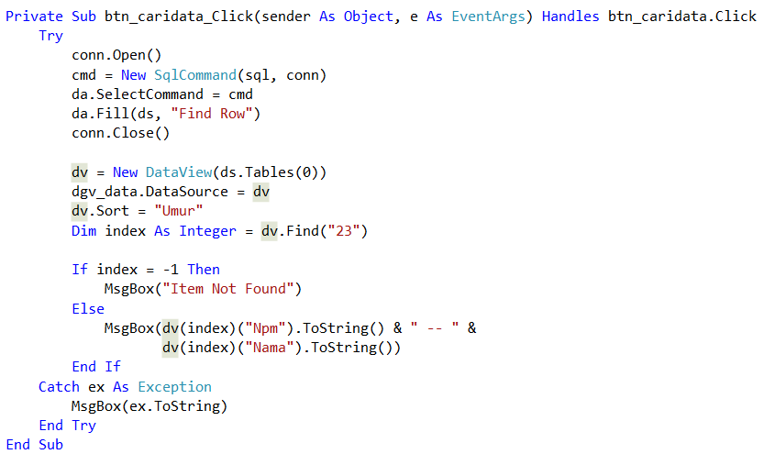

**Try**

**conn.Open()**

**cmd = New SqlCommand(sql, conn)**

**da.SelectCommand = cmd**

**da.Fill(ds, "Find Row")**

**conn.Close()**

**dv = New DataView(ds.Tables(0))**

**dgv_data.DataSource = dv**

**dv.Sort = "Umur"**

**Dim index As Integer = dv.Find("23")**

**If index = -1 Then**

**MsgBox("Item Not Found")**

**Else**

**MsgBox(dv(index)("Npm").ToString() & " -- " &**

**dv(index)("Nama").ToString())**

**End If**

**Catch ex As Exception**

**MsgBox(ex.ToString)**

**End Try**

**– Codingan btn_tambahbaris–**

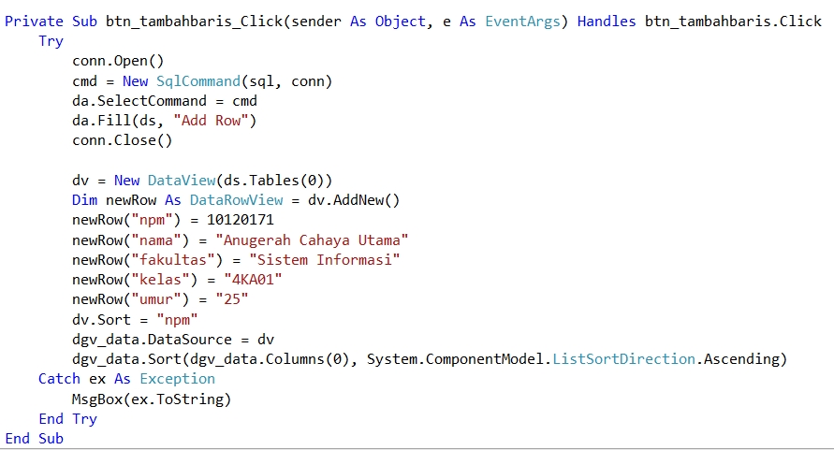

**Try**

**conn.Open()**

**cmd = New SqlCommand(sql, conn)**

**da.SelectCommand = cmd**

**da.Fill(ds, "Add Row")**

**conn.Close()**

**dv = New DataView(ds.Tables(0))**

**Dim newRow As DataRowView = dv.AddNew()**

**newRow("npm") = 10120171**

**newRow("nama") = "Anugerah Cahaya Utama"**

**newRow("fakultas") = "Sistem Informasi"**

**newRow("kelas") = "4KA01"**

**newRow("umur") = "25"**

**dv.Sort = "npm"**

**dgv_data.DataSource = dv**

**dgv_data.Sort(dgv_data.Columns(0), System.ComponentModel.ListSortDirection.Ascending)**

**Catch ex As Exception**

**MsgBox(ex.ToString)**

**End Try**

**– Codingan btn_ubahdata –**

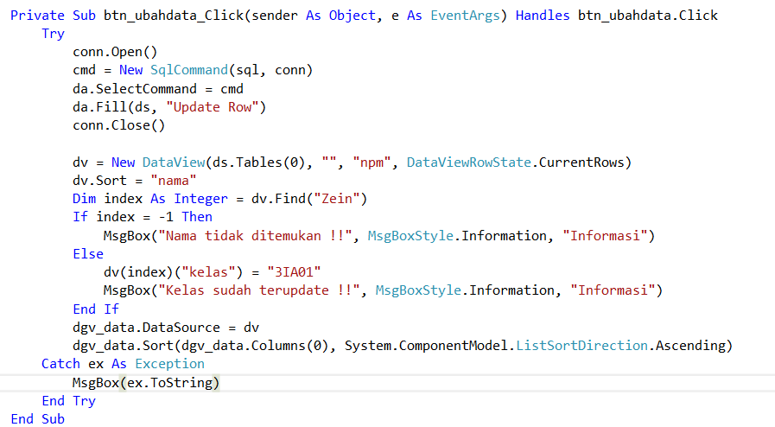

**Try**

**conn.Open()**

**cmd = New SqlCommand(sql, conn)**

**da.SelectCommand = cmd**

**da.Fill(ds, "Update Row")**

**conn.Close()**

**dv = New DataView(ds.Tables(0), "", "npm", DataViewRowState.CurrentRows)**

**dv.Sort = "nama"**

**Dim index As Integer = dv.Find("Zein")**

**If index = -1 Then**

**MsgBox("Nama tidak ditemukan !!", MsgBoxStyle.Information, "Informasi")**

**Else**

**dv(index)("kelas") = "3IA01"**

**MsgBox("Kelas sudah terupdate !!", MsgBoxStyle.Information, "Informasi")**

**End If**

**dgv_data.DataSource = dv**

**dgv_data.Sort(dgv_data.Columns(0), System.ComponentModel.ListSortDirection.Ascending)**

**Catch ex As Exception**

**MsgBox(ex.ToString)**

**End Try**

**– Codingan btn_hapusdata –**

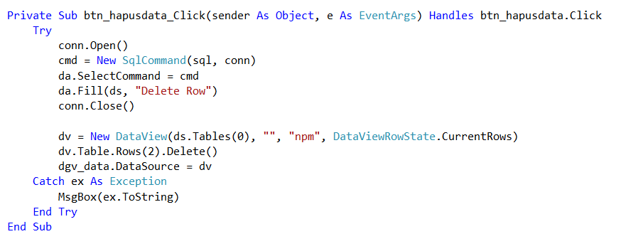

**Try**

**conn.Open()**

**cmd = New SqlCommand(sql, conn)**

**da.SelectCommand = cmd**

**da.Fill(ds, "Delete Row")**

**conn.Close()**

**dv = New DataView(ds.Tables(0), "", "npm", DataViewRowState.CurrentRows)**

**dv.Table.Rows(2).Delete()**

**dgv_data.DataSource = dv**

**Catch ex As Exception**

**MsgBox(ex.ToString)**

**End Try**

**Panduan Screenshot**

* **Design**
* **Codingan Setiap Button**
* **Output Cari Data, Tambah Baris, Ubah Data, Hapus Data**